**ANALYSIS OF HOMELESSNESS IN THE U.S.**

**INTRODUCTION:**

Homelessness has now evolved into a pressing public health and humanitarian crisis in the United States. According to the Department of Housing and Urban Development, on a given night in December 2023, 653,104 people were experiencing homelessness-the largest number on record to date. This project is motivated by the urgent need to understand the driving factors of homelessness and possible solutions.  
  
It has traditionally been misconstrued that homelessness is a personal failing, whereas modern research points out systemic contributing factors including increased housing costs, economic downturns, and public health crises. These factors have worsened since the 1980s, creating a complex situation for which intervention requires an in-depth analysis.

This project focuses on four key areas:

1. Visualizing the number of individuals experiencing homelessness to highlight its scope.
2. Mapping the concentration of homelessness across states to identify the most affected areas.
3. Analyzing the impact on diverse population groups by race, gender, family structure, and veteran status.
4. Comparing housing demand with available shelter supply to identify resource gaps

The aims of this project are to:

* Simplify the complexity of homelessness for better understanding.
* Propose improvements to housing inventory to address the shelter shortage.
* Highlight the disproportionate impact on marginalized groups and suggest equitable strategies.

**DATA SET:**

|  |  |  |
| --- | --- | --- |
| **Dataset** | **Feature** | **Description** |
| 1. Primary: Point-in-time estimate of homelessness, Housing Inventory, Homelessness estimations for veterans | Dataset source | huduser.gov/portal/sites/default/files/xls/2007-2023-PIT-Counts-by-State.xlsb |
| Associated body (funding, purpose) | US Dept of Housing and Urban Development’s Policy wing funds and prepares an Annual Homelessness Assessment Report to present to Congress. Data collected by social impact research firm [ABT Global](https://www.abtglobal.com/who-we-are) |
| Timeline / Lineage of data | The AHAR was established in 2002, with data regularly reported since 2007. The dataset provides estimates for each year from 2007-2023. |
| How large is the dataset (cases, variables)? | * Years: 2007-2023 * Race: 7 * Gender: M, F, TG, Gender questioning * Age groups: * Veteran status data * Sheltered/unsheltered data |
| Locations | National and state-level data. |
| 2. Zillow Observed Rent Index (ZORI) | | Zillow Research conducts independent studies, including the Zillow Observed Rent Index (ZORI), which measures typical market rent rates in a region. ZORI is a repeat-rent index weighted by the rental housing stock, ensuring it represents the entire market—not just listed homes. It includes data on rentals in the 35th-65th percentile and reflects prices of rentals not listed on Zillow. For our visualization, we are using county-level data. |
| 3. US Population estimate | | [US Census Bureau](https://www.census.gov/data/tables/time-series/demo/popest/2020s-state-detail.html) provides population estimates by state, race, and age. We used a pivot table to isolate relevant data for 2023 |

**DATA STORY:**

1. **Rank of Homelessness by State - 2023**

We created a symbol map in Tableau to visually compare the rates of homelessness in U.S. states. The map enables a clear picture of the percentage of homeless individuals related to the total population in each state. We then rank the states based on such figures and color code based on the severity of homelessness.

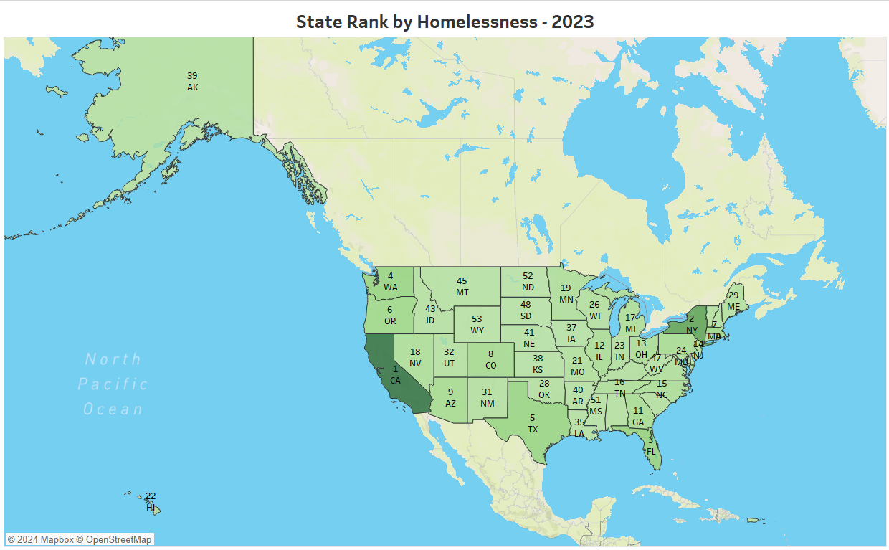

**1. Data Set:**

**Primary Data**: The main dataset is a *Point-in-time estimate of homelessness* provided by the U.S. Department of Housing and Urban Development (HUD), specifically from the *Annual Homelessness Assessment Report (AHAR)* prepared by ABT Global, a social impact research firm.

* **Source**: The dataset can be found at [huduser.gov](https://huduser.gov/portal/sites/default/files/xls/2007-2023-PIT-Counts-by-State.xlsb).

**Secondary Data**: To determine the total population of each state, we used U.S. Census Bureau estimates for the year 2023. This gave us a contextual framing for homelessness data in relation to the total population.

* **Source**: U.S. Census Bureau

**2. Variables & Definitions:**

* **State Code (State1)**: A short code representing each U.S. state.
* **Overall Population**: The total population of each state.
* **Overall Homeless**: The total number of homeless individuals in each state.
* **Percentage of Homelessness**: This field is the key metric visualized and used to indicate the proportion of homeless individuals to the state’s population. This is calculated as below:

*Percentage of Homelessness = (Overall Homeless / Overall Population) * 100*

* **Rank**: Each state is ranked based on homelessness in ascending order.

**3. Limitations:**

* **Timeframe**: The data is from 2023, so it only captures homelessness trends for that year. It does not provide insights into changes over time.
* **Granularity**: The visualization is at the state level, so it does not provide any regional or city-level insights where homelessness could be more concentrated.
* **Homelessness Definition**: The exact definition of "homelessness" may vary depending on how each state reports data.
* **Comparative Insights**: While ranks are useful for comparison, more detailed statistics, like the raw number of homeless individuals or specific contributing factors, would provide a deeper analysis.

**4. How the chart addresses the goal:**

* The chart effectively visualizes homelessness across different U.S. states, making it easy to compare states by homelessness levels.
* The color intensity on the map helps identify states with higher homelessness. For example, darker states like California and New York are easily noticeable.
* By incorporating the rank field, the chart provides a clear visual indicator of which states have the most significant homelessness problems, addressing the goal of quickly identifying and comparing states based on homelessness.

1. **Trend of Homelessness by gender & age**

We created two different visualizations, displayed together in a dashboard, to present demographic information on homelessness in 2023, specifically focusing on gender and age. For gender we created a highlight table that displays the percentage of homeless across the years for each of the 4 gender categories (Male, Female, Transgender, Gender not Female or Male). The color scheme of the table allows for easy identification of which gender is predominant.

Additionally, we created a pie chart to represent the total number of homeless by age groups. This visualization effectively highlights the differences in homelessness across age groups.

**1. Data Set:**

**Primary Data**: The main dataset is a *Point-in-time estimate of homelessness* provided by the U.S. Department of Housing and Urban Development (HUD), specifically from the *Annual Homelessness Assessment Report (AHAR)* prepared by ABT Global, a social impact research firm.

* **Source**: The dataset can be found at [huduser.gov](https://huduser.gov/portal/sites/default/files/xls/2007-2023-PIT-Counts-by-State.xlsb).

**Secondary Data**: To determine the total population of each state, we used U.S. Census Bureau estimates for the year 2023. This gave us a contextual framing for homelessness data in relation to the total population.

* **Source**: U.S. Census Bureau

**2. Variables & Definitions:**

**a. Gender Highlight Table**

* **Gender:** Each of the 4 genders as a different row in the table.
* **Year:** Evolution across the year 2019-2023.
* **Overall Homeless Number**: The total number of homeless individuals in each gender by year.
* **Overall Homeless Percentage**: The total percentage of homeless individuals in each gender by year.

**b. Age Distribution Pie Chart**

* **Age:** Each of the 4 age groups as a different portion of the pie chart.
* **Overall Homeless Number**: The total number of homeless individuals in each age-group.
* **Overall Homeless Percentage**: The total percentage of homeless individuals in each age-group.

**3. Limitations:**

**a. Gender Highlight Table**

* **Granularity**: The data is presented at a high level without offering more localized insights, such as state- or city-level trends where homelessness could be more pronounced.
* **Homelessness Definition**: The exact definition of "homelessness" may vary depending on how each state reports data.
* **Lack of Explanation for Changes**: The data shows significant fluctuations in homelessness numbers in some years (e.g., 2021), but it does not explain the factors behind these changes.

**b. Age Distribution Pie Chart**

* **Timeframe**: The chart provides a static view for 2023, missing the trend over time, which could be useful to understand how it has changed the overall homeless by age group across the years.
* **Data Granularity**: The dataset lacks granularity by not specifying the gender by each age group, which would have provided a better insight into which demographic category the government should implement policies.
* **Lack of Explanation of Contributing Factors:** The data shows age distribution, but does not explain why certain age groups might be over- or underrepresented.

**4. How the chart addresses the goal:**

**a. Gender Highlight Table**

* The chart effectively visualizes overall homelessness by gender from 2019-2023., making it easy to compare gender by homelessness levels.
* Color Highlights the consistent dominance of male gender homelessness, making easy to understand the difference between genders.
* By Including underrepresented groups (transgender and non-binary), the table offers a more comprehensive gender breakdown.
* The chart’s focus on both absolute numbers and percentages helps provide a dual understanding of volume and proportional change.

**b. Age Distribution Pie Chart**

* Visualizes the distribution of homeless individuals across broad age categories, helping to easily see which age groups are most affected.
* Using a pie chart format helps to emphasize the proportion of each group relative to the whole population.
* The chart’s layout helps achieve the goal of quickly identifying the most affected age groups.

1. **Trends in Homelessness by Race (2019-2023)**

This line chart visualizes the trends in homelessness distribution across various racial groups in the U.S. from 2019 to 2023. It tracks the percentage of homeless individuals within each racial group in relation to the total homeless population over this period.

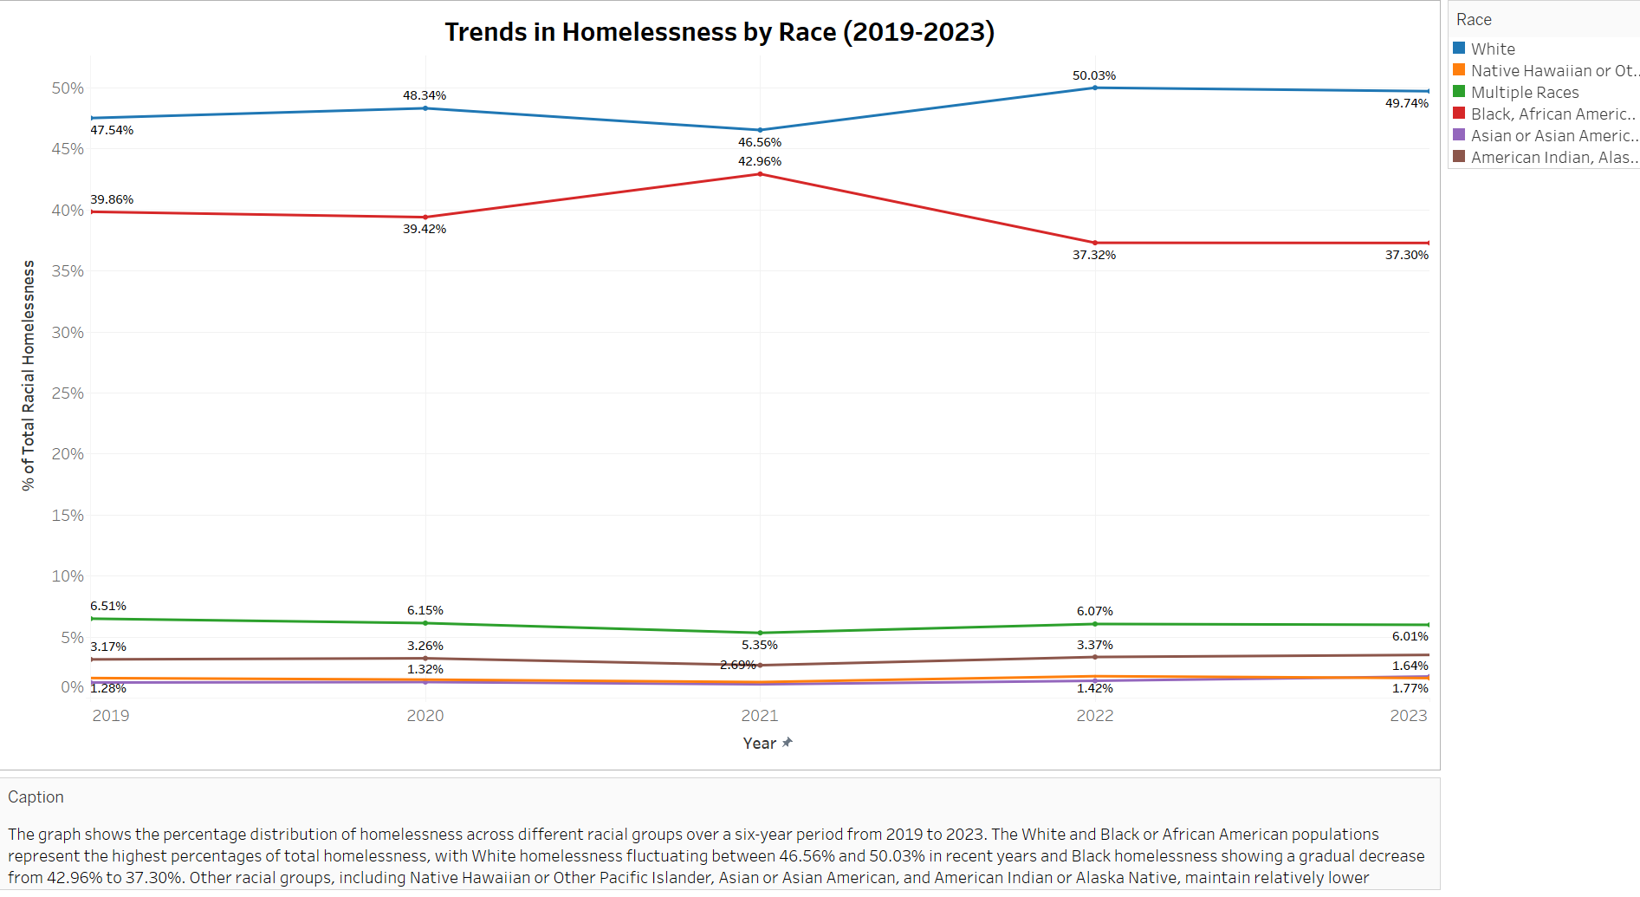

**1. Data Set:**

**Primary Data**: The data used for this analysis was sourced from the U.S. Department of Housing and Urban Development’s (HUD) Annual Homelessness Assessment Report (AHAR). The report provides point-in-time estimates of homelessness across the U.S., disaggregated by race.

* Source: HUD, AHAR.

**Secondary Data**: No secondary data was required for this specific visualization as it focuses solely on HUD’s racial homelessness breakdown.

**2. Variables & Definitions:**

* Racial Groups: The chart includes data for six racial groups: White, Black or African American, Native American, Multiracial, Asian, and Pacific Islander.
* % of Total Racial Homelessness: This is the key metric visualized, representing the percentage of the total homeless population belonging to each racial group.

**Key Insights:**

* White Homelessness: This group consistently represents the largest share of the total homeless population, fluctuating between 46.56% and 50.03% over the six-year period.
* Black Homelessness: The Black or African American population consistently holds the second-largest share, with percentages hovering around 37%, showing a slight decline from 39.86% in 2019 to 37.30% in 2023. While absolute numbers show that white Caucasian Americans have highest numbers experiencing homelessness, as a proportion of the population, African Americans are disproportionately affected by homelessness. They make about 15% of the population but nearly 40% of those experiencing homelessness.
* Native American and Multiracial Populations: These groups show smaller percentages, but still maintain noticeable representation, with Native American homelessness slightly decreasing from 6.51% to 6.01%, and multiracial individuals holding steady around 3.3% to 3.5%.
* Other Races: Asian and Pacific Islander populations have the smallest shares of homelessness, with percentages remaining relatively stable around 3% or less.

**3.Limitations:**

* Timeframe: The data only captures trends from 2019 to 2023, meaning it may not provide long-term historical context for changes in racial homelessness.
* Granularity: The data is aggregated at the national level, and does not provide insights into how racial homelessness trends vary across specific regions, states, or cities.

**4.How the Chart Addresses the Goal:**

* The chart highlights the racial disparities in homelessness, making it easy to compare trends over time. White and Black or African American individuals consistently represent the largest percentages of the homeless population, with White homelessness fluctuating between 46.56% and 50.03%, and Black homelessness showing a slight decline from 39.86% to 37.30%.
* This visual clearly indicates which racial groups are disproportionately affected, providing useful insights for policy discussions. The color-coded lines emphasize which groups are most impacted, helping to prioritize intervention efforts based on racial inequities.

1. **Rental price and rates of homelessness**

This line chart demonstrates the change in rental prices over the period 2019 to 2023, and the corresponding change in rates of homelessness during the same period. The visualization shows clearly that every increase in average rental prices for each state, there is a corresponding increase in homelessness. For the years 2022-2023 the increase is even sharper. This trend offers credence to the claim that homelessness is primarily an issue arising out of housing crisis, not just an individual’s lack of will and financial mismanagement. Housing prices have been on an upward trajectory, making housing unaffordable for more people. According to Zillow, this has a spillover effect, where individuals who were previously able to afford housing in affordable units get pushed out of the housing market by those who downgraded their housing to those units once rents went up in their original units.

**1.Data set:**

**Primary Data**: for this visualization comes from [Zillow’s Observed Rent Index](https://www.zillow.com/research/data/), which provides data on month-wise median rent per county for years 2019-2023. We pivoted this data to get the aggregate measure of median rent per year per state to compare this data with the homelessness rate per year per state.

* Source: Zillow’s Observed Rent Index

**Secondary Set**: the data set represents the homelessness numbers is from HUD

**2.Variables & Definitions:**

* The line chart is visualized basis the percentage of change in aggregate median rent per state and percentage change in the aggregate homelessness number against each year from 2019-2023. Thus, a percentage increase in rent is accompanied by a percentage increase in homelessness

**3.Limitations:**

* Since the homelessness numbers are Point-In-Time estimates from HUD, for the year 2021, the estimates reflect only the people experiencing homelessness *in shelters.* On account of COVID restrictions, several shelters were not in service, and unsheltered homeless people are not accounted for in this figure. While rental prices did reduce on account of CARES act and eviction moratoriums placed during COVID, the number of people experiencing homelessness likely reduced too, but we cannot be certain about the degree of reduction

**4.How the chart addresses the goal:**

* The line chart is an appropriate representation since it effectively shows the delta in rent and homelessness *over time.*
* It shows us a **macro-level** detail and insight into a potential cause of homelessness as lack of rent affordability, which can in turn be used to inform policy

1. **Beds Available vs. Homeless Population by State in 2023**

This bullet bar chart illustrates the comparison between the number of available beds and the total homeless population in the top 10 U.S. states for homelessness in 2023. California ranks highest with 4,97, 917 available beds but also has the largest homeless population at 12,69,793, revealing a significant shortage. States such as Oregon, Florida, and Washington display similar, though smaller, gaps between bed availability and homelessness.

**1. Data Set:**

**Primary Data**: The main dataset is a *Point-in-time estimate of homelessness* provided by the U.S. Department of Housing and Urban Development (HUD), specifically from the *Annual Homelessness Assessment Report (AHAR)* prepared by ABT Global, a social impact research firm.

* **Source**: The dataset can be found at [huduser.gov](https://huduser.gov/portal/sites/default/files/xls/2007-2023-PIT-Counts-by-State.xlsb).

**Secondary Data**: To determine the shelter availability of each state, we used U.S. Census Bureau estimates for the year 2023. This gave us a contextual framing for homelessness data in relation to the total population.

* **Source**: U.S. Census Bureau

**2. Variables:**

* **State Code (State1)**: A short code representing each U.S. state.
* **Overall Homeless**: The total number of homeless individuals in each state.
* **Total Beds**: This field is the total available beds across the states including emergency shelters, transitional housing and safe haven.
* **Beds Available vs Homeless People**: This field is the key metric visualized and used to indicate the homeless individuals who do not have a shelter available for them. This is calculated as below: Beds Available vs Homeless People = Overall Homeless – Total Beds (ES, TH, SH)

**3. Limitations:**

* **Timeframe**: The chart provides a static view for 2023, missing the trend over time, which could be useful to understand whether bed availability is improving, declining, or remaining constant.
* **Data Granularity**: The dataset lack granularity by not specifying the type of beds (emergency shelter, transitional housing, permanent supportive housing), which can affect the accuracy of interpreting available resources for homelessness.
* **Data Specificity**: This snapshot only shows the top 10 U.S. states, which could overlook insights from other states.

**4. How the chart addresses your goal**

* **Visual Comparison**: The bullet bar representation of beds available and homeless population provides an immediate visual cue to identify disparities between resources and needs.
* **Direct Insight into Disparities**: The contrasting colors for beds and homeless population effectively emphasize the magnitude of gaps, especially in states like California, facilitating quick comprehension of critical issues.
* **Top 10 States for Contextual Relevance**: The chart’s focus on the top 10 states with the highest homelessness rates ensures the data remains relevant and impactful, targeting areas with the most pressing needs.

1. **Homelessness in Veterans over time (2007-2023)**

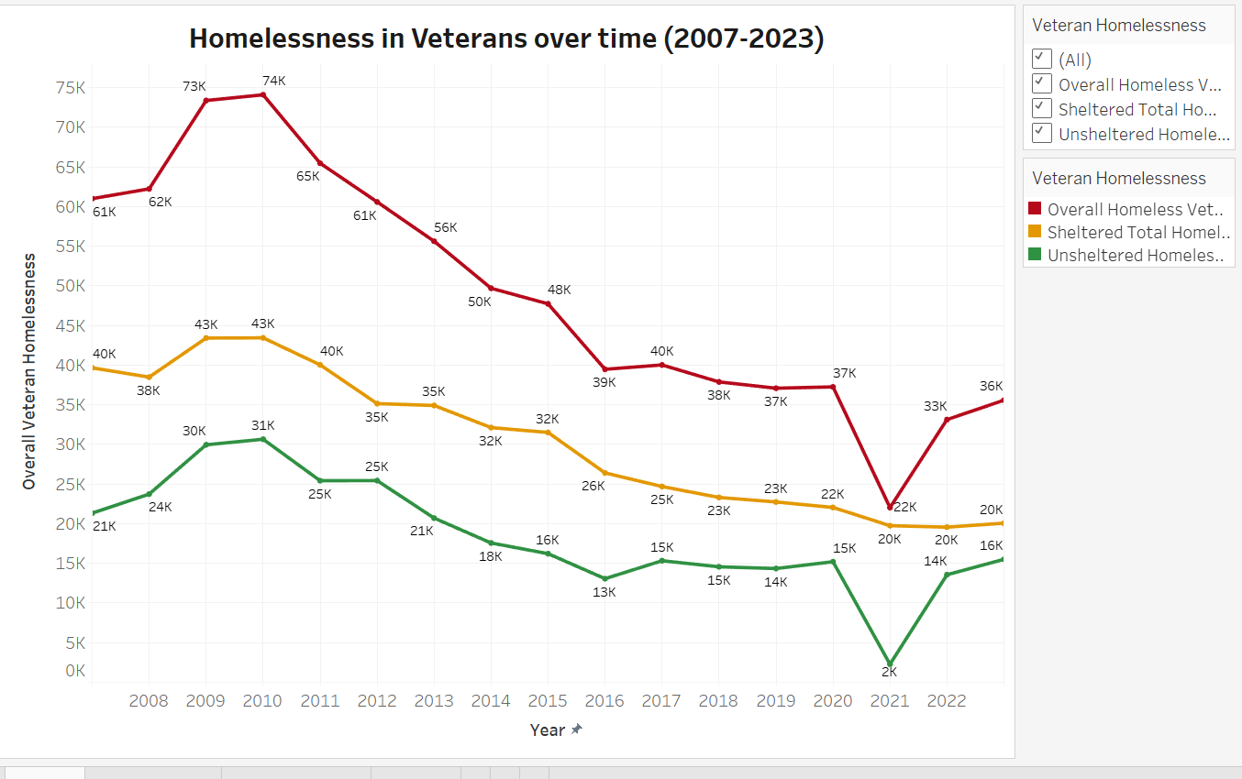

**1. Data Set:**

**Primary Data**: The main dataset is the Point-in-time estimate of veteran homelessness provided by the U.S. Department of Housing and Urban Development (HUD) through the Annual Homelessness Assessment Report (AHAR), prepared by ABT Global, a social impact research firm. This dataset focuses specifically on the population of homeless veterans across the United States.

* **Source**: HUD’s dataset can be accessed at [huduser.gov](https://huduser.gov).

**2. Variables & Definitions:**

* **Overall Homeless Veterans**: The total number of veterans experiencing homelessness, both sheltered and unsheltered, in each year from 2007 to 2023.
* **Sheltered Total Homeless Veterans**: The total number of homeless veterans residing in emergency shelters, transitional housing, or other temporary shelters during the annual Point-in-time count.
* **Unsheltered Homeless Veterans**: The number of homeless veterans living in places not meant for human habitation (e.g., streets, cars, parks).
* **Year**: The dataset includes a 16-year timeline (2007–2023), allowing for an analysis of trends over time.

**3. Limitations:**

* **Pandemic-Related Data Gaps**: The figures for 2021 primarily reflect sheltered homelessness due to the COVID-19 pandemic, which led to the cancellation of many unsheltered counts to reduce health risks. This limitation might contribute to an artificial dip in 2021 numbers.
* **Focus on Veterans**: While the data provides deep insights into veteran homelessness, it does not capture the homelessness trends of other vulnerable demographics, limiting its generalizability.
* **Data Collection Limitations**: The PIT counts rely on the capacity of local communities and volunteers, which can affect the consistency and accuracy of data collected, especially in under-resourced areas.

**4. How the chart addresses your goal:**

* **Visual Representation of Veteran Homelessness Trends**: The chart tracks veteran homelessness from 2007 to 2023, effectively showcasing how dedicated federal programs have significantly reduced the number of veterans experiencing homelessness, particularly after 2010.
* **Targeted Solutions and Government Programs**: The sharp declines in unsheltered and sheltered homelessness emphasize the impact of programs like the Veterans Affairs Supportive Housing (VASH) and the Supportive Services for Veteran Families (SSVF) programs. These programs' focus on rapid rehousing and vouchers plays a critical role in reducing homelessness, highlighted by the downward trends in the chart.
* **Highlighting Systemic Solutions**: The chart visualizes the success of veteran-targeted initiatives, supporting the broader argument that dedicated funding and support, like housing vouchers, can be effective in tackling homelessness on a larger scale.

This visualization serves as an evidence-based example of the success of intervention programs, illustrating how targeted solutions can lead to significant progress in reducing homelessness.

**CONCLUSION:**

In conclusion, homelessness in America is largely driven by an affordability and availability crisis rather than individual financial mismanagement. The lack of affordable housing and the insufficient supply of accessible options continue to push vulnerable populations into homelessness. To address this, it is essential to expand dedicated funding for rehousing initiatives, ensuring resources are available for rapid rehousing and long-term support. Additionally, implementing a targeted approach, similar to the successful model used for veterans, can help provide tailored support for at-risk groups, ultimately creating a more effective and sustainable path out of homelessness.